Project Edulead

**USER MANUAL**

**Student Lifecycle Management System**

**Module-Academics**

**

**Sustainable Outreach and Universal Leadership Limited**

**Sign off Date Signature Client Signature Consulting**

# 

Table of Contents

About this Manual 3

Module: Academics 4

1. Group & Schedules 4

1.1 Student Group 4

1.2 Subject Schedule 7

2. Attendance & Leave Application 9

2.1 Student Attendance 9

2.2 Student Leave Application 10

3. Tools 12

3.1 Subject Scheduling Tool 12

3.2 Student Attendance Tool 14

4. Assignment & Study Materials Upload 15

4.1 Assignment Master 16

4.2 Upload Materials 17

4.3 Received Assignment 19

5. Feedback 21

5.1 Teacher's Feedback 21

5.2 Admin Changes 23

# About this Manual

This User Manual acts as a reference for ERP- **EduLead** by describing its various concepts and abilities, and by leading the user through the basics of **EduLead** software. It also provides a detailed reference for all of the **EduLead** SLCM (Student Lifecycle Management) functionalities. The User Manual describes all the processes and functionalities regarding various modules and its abilities to conduct the smooth transactions and integrations within the modules.

The software **EduLead** is open-source, easy to use and customize, actively maintained, economical and well supported. Throughout this manual it is assumed that the reader has a working knowledge of about Student Lifecycle Management and basic computer skills and knows how to:

* Use keyboard and mouse
* Use web browsers to access the **EduLead** website
* Locate, open and save data files.
* Edit, cut, paste and text.

The SLCM consists of 3 Modules mainly:

1. Admission
2. Academics
3. Examination

This User Manual consists of the **Academics Module** for End User reference and guidance. The manual describes how to use the Standard interface. As mentioned, it contains instructions that the users must follow during the operation and servicing of **EduLead**. Diverting from the workflow as mentioned in the user manual may result in errors and non-functioning of the software EduLead. It is advisable that the end users must abide by the instructions as mentioned in the user manual.

# Module: Academics

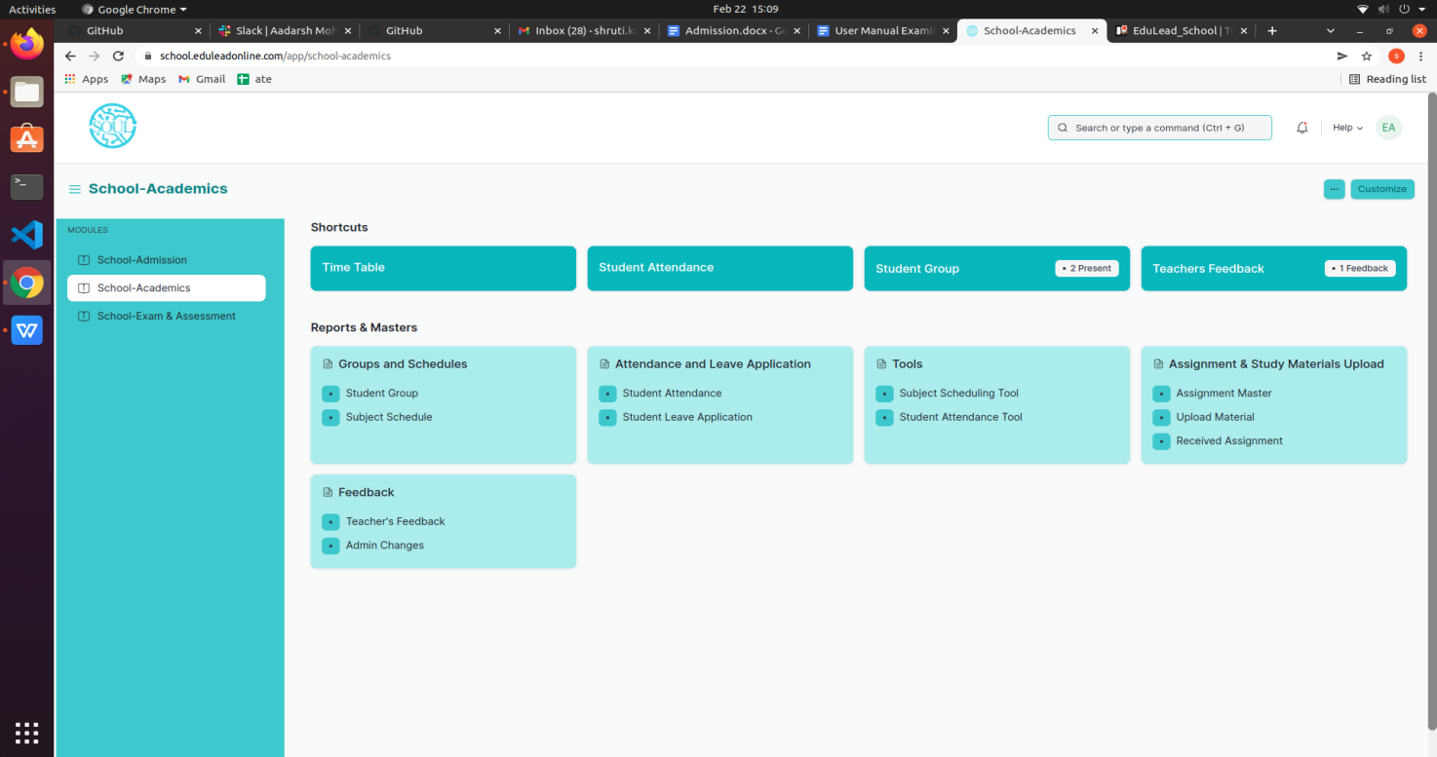

## Groups & Schedules

Groups & Schedules consist of transactions which would allow to form a student group based on various criteria for a particular class and help to schedule classes for different subjects for different classes. The transactions in Groups & Schedules consists of:

1. Student Group
2. Course Schedule
3. Student Log

### 1.1 Student Group

The Student Group allows you to create a group of students for different classes for the ongoing Academic Year based on different criterion like:

* 1. Batch
  2. Exam Declaration
  3. Course
  4. Activity
  5. Combined Course
  6. Mentor-Mentee

To access the Student Group Process, go to:

Home > Academics > Group & Schedules > Student Group

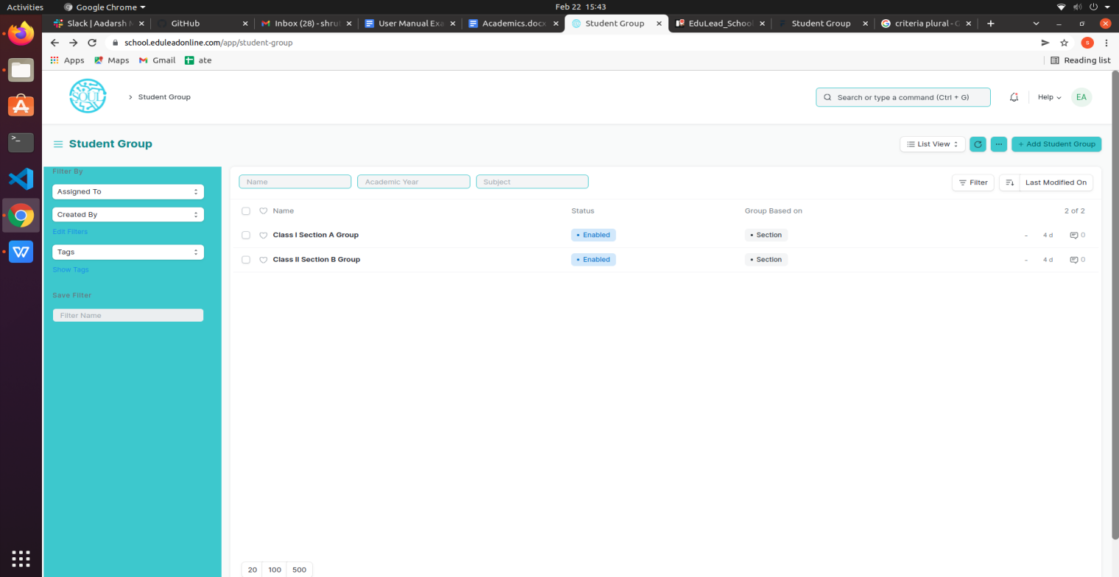

#### Prerequisites

Before creating a Student Group, it is advisable that you create the following first:

1. Student
2. Class Enrollment
3. Student Batch Name
4. Student Category
5. Instructor

#### How to create a Student Group?

1. Go to the Student Group list and click on ‘Add Student Group’
2. Select and enter the Academic Year
3. Select and choose from the drop-down list for ‘Group Based on’.
4. Batch- Select and enter Class, Section and Batch (from the drop-down).
5. Subject- Select and enter Class, Section and Subject (from the drop-down).
6. Section- Select and enter Class and Section.
7. Activity- Select and enter Class and Section.
8. Exam Declaration- Select and enter Class, Subject and Exam Declaration.
9. Enter the name for the Student Group
10. Select and Enter the classroom from the drop-down list.
11. Select and Enter the maximum strength.
12. Select and Enter the Student Category(ST/General) from the drop-down list.
13. In the ‘Teacher’ table, enter the details like Subject and associated Teachers for the particular Class or Section.
14. Save.
15. Click on the ‘Get Student’ button, all the students present will automatically be fetched on the basis of ‘Group Based On’.

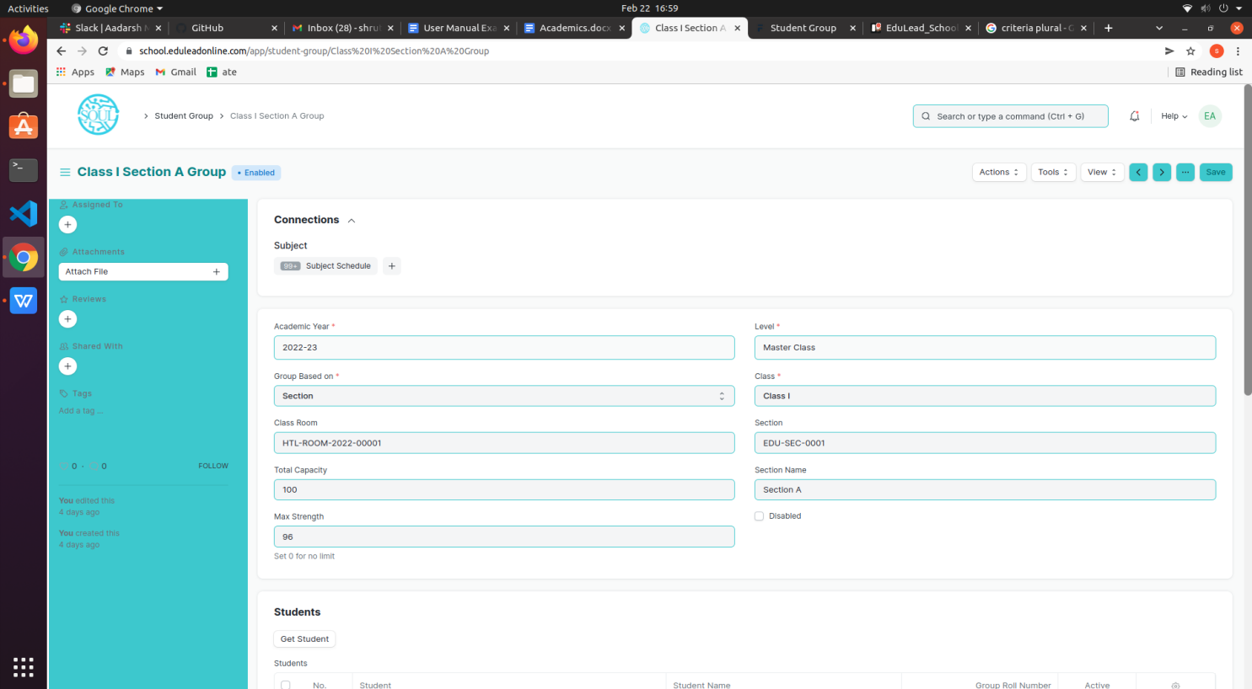

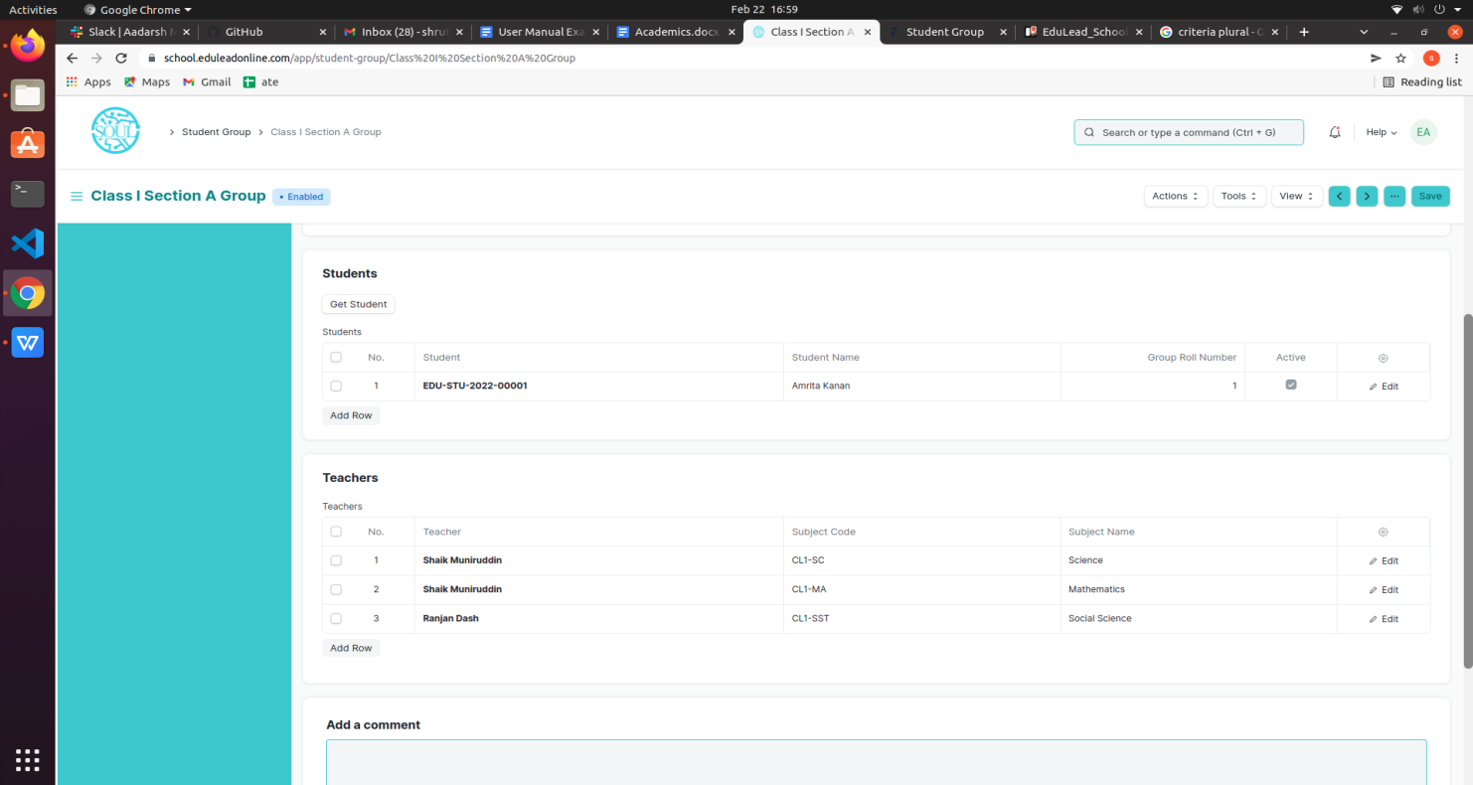

**1.2 Course Schedule**

The Course Schedule can be used for scheduling a particular subject by an Instructor or Education Administrator.

Using this feature, a timetable can be created for a University, wherein each slot will be scheduled via Course Schedule.

To access the Course Schedule, go to:

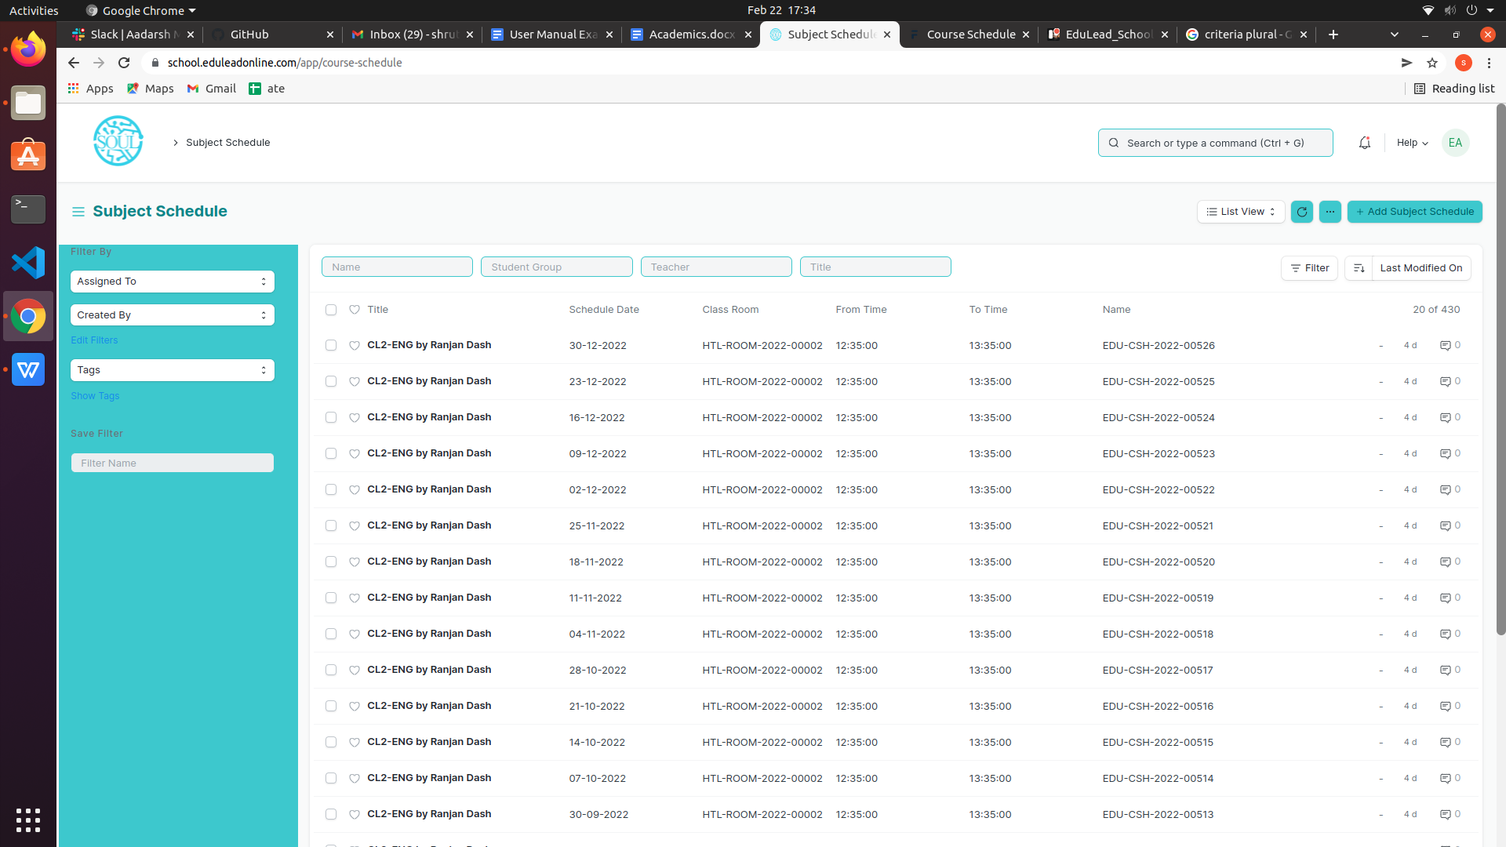Home > Academics > Group & Schedules > Course Schedule

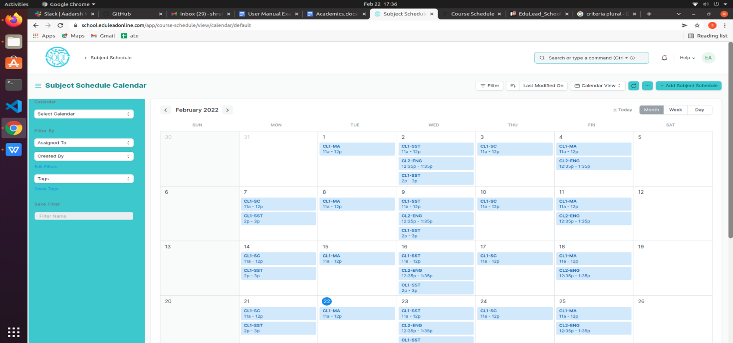

#### Prerequisites

Before creating an Subject Schedule, it is advisable that you create the following first:

1. Student Group
2. Teacher
3. Subject
4. Class
5. Classroom

#### How to create a Subject Schedule?

1. Go to the Subject Schedule list and click on ‘Add Subject Schedule’.
2. Select and enter the Student Group.
3. Select and enter the Teacher who will be tutoring the students for the subject.
4. Select and enter the Subject from the drop down menu for which the schedule is being prepared.
5. Select and Enter the ‘From Time’ and ‘To Time’for the subject schedule .
6. Select and Enter the Classroom wherein the class could be conducted..
7. Save.

**Note: Subject Scheduling Tool can be used for bulk scheduling of a subject. **

## Attendance and Leave Application

Attendance and Leave Application consists of transactions which would allow to mark attendance for a particular student of a class and keep the track of leaves for a student. The transactions in Attendance and Leave Application consists of:

1. Student Attendance
2. Student Leave Application

### 2.1 Student Attendance

The Student Attendance allows you to keep track and mark the attendance of a student for a day.Attendance records can be created against Students on a daily basis.

To access the Student Attendance process, go to

Home > School- Academics > Attendance and Leave Application > Student Attendance

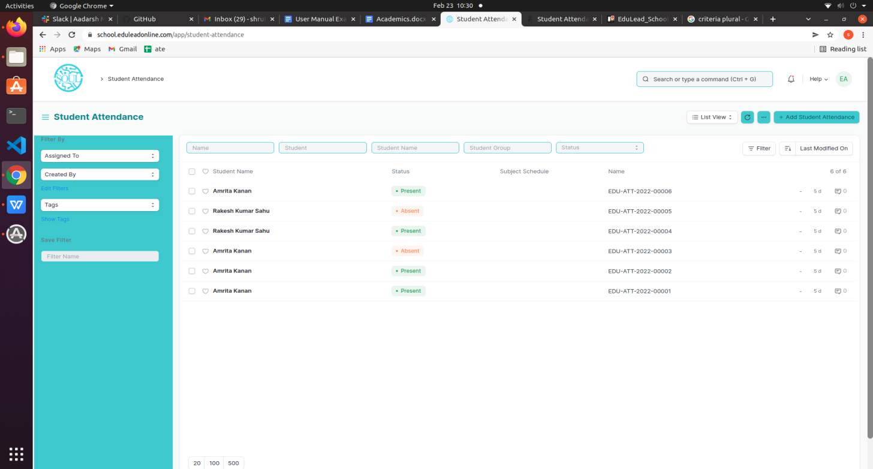

#### 

#### 

#### 

#### Prerequisites

Before creating a Student Attendance, it is advisable that you create the following first:

1. Student
2. Subject Schedule
3. Student Group

#### How to create a Student Attendance?

1. 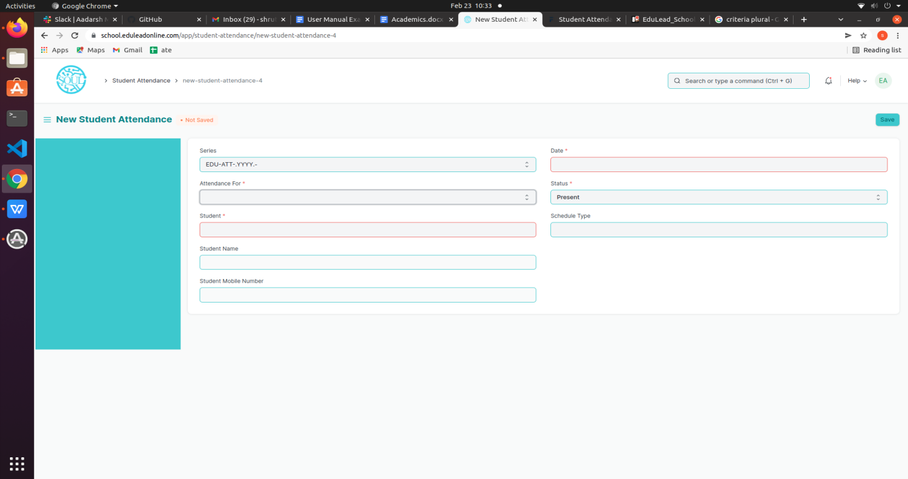Go to the Student Attendance list and click on ‘Add Student Attendance’.
2. Select and enter the Student.
3. Select and enter date and subject.
4. Select and enter the Student Group and Subject Schedule.
5. Set the Status to Present/Absent/On Leave .
6. Save and Submit.

**Note: The Attendance can be marked for the Exams also

Student Attendance Tool can be used for bulk updation of the attendance. **

### 2.2 Student Leave Application

The Student Leave Application allows you to keep a track of leaves for a Student.

To access the Student Leave Application process, go to

Home > School- Academics > Attendance and Leave Application > Student Attendance

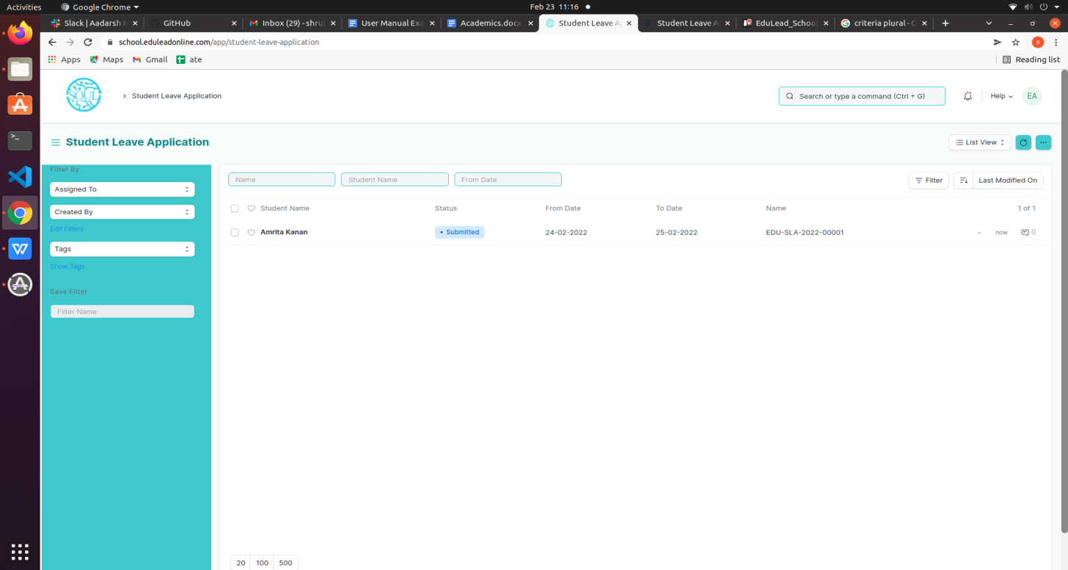

#### 

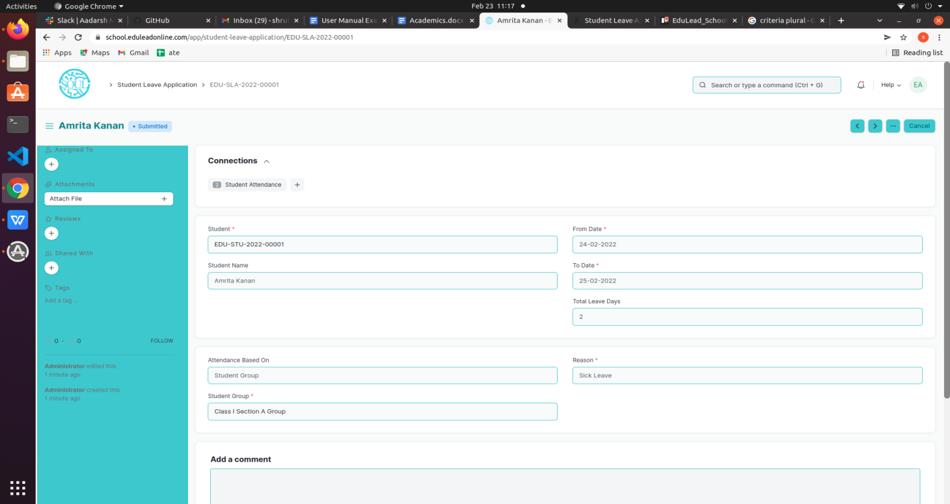

#### Prerequisites

Before creating a Student Leave Application, it is advisable that you create the following first:

1. Student
2. Student Group

#### How to create a Student Leave Application?(From Student Login)

1. Go to the Student Leave Application list and click on ‘Add Student Leave Application’.
2. Student details like Student Name,Student ID,Student Group will be auto-fetched.
3. Select and enter From Date and To Date.
4. Select and enter Reason .
5. Save .

**Note: The Attendance will be marked automatically**

## Tools

### 3.1 Subject Scheduling Tool

The Subject Scheduling Tool allows you to create Subject Schedules in bulk for the particular Subject.

To access the Student Scheduling Tool process, go to

Home > School- Academics > Tools > Subject Scheduling Tool

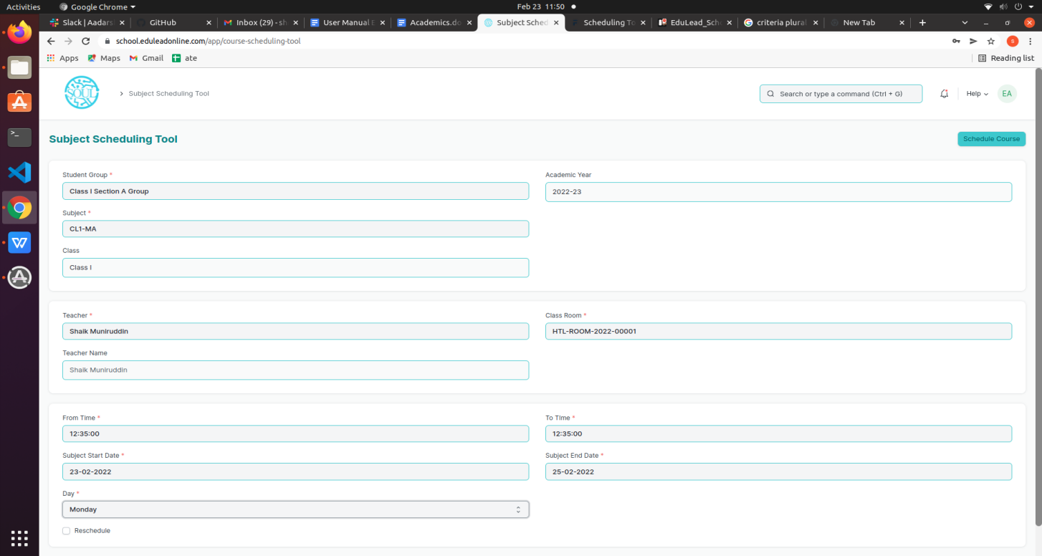

#### Prerequisites

Before using Subject Scheduling Tool, it is advisable that you create the following first:

1. Student Group
2. Teacher
3. Subject
4. Class
5. Classroom

#### How to use a Subject Scheduling Tool?

1. Go to the Subject Scheduling Tool.
2. Select and enter the Student Group.
3. Select and enter the Teacher who will be tutoring the students for the subject.
4. Select and enter the Subject from the drop down menu for which the schedule is being prepared.
5. Select and Enter the ‘From Time’ and ‘To Time’for the subject schedule .
6. Select and Enter the Start Date and End Date of the Subject..
7. Select and Enter the Day.
8. Click on ‘Schedule Subject’ Button.

**Note: The system will create the subject schedules if the classroom and teacher are available and there is no conflict for the selected Student Group with other subject schedules.**

#### Rescheduling:

1. You can reschedule the subject schedules created.
2. Check the ‘Reschedule Checkbox and then click on ‘Schedule Subject’.
3. System will delete the existing Subject Schedules for the particular Subject within the mentioned Start Date and End Date and will create a new Subject Schedules.

The entries for all the Subject Scheduling Tools are created in the Subject Schedule Document.

### 3.2 Student Attendance Tool

The Student Attendance Tool allows you to bulk update the Attendance for Students based on Student Group and Subject Schedule.

To access the Student Attendance Tool process, go to

Home > School- Academics > Tools > Student Attendance Tool

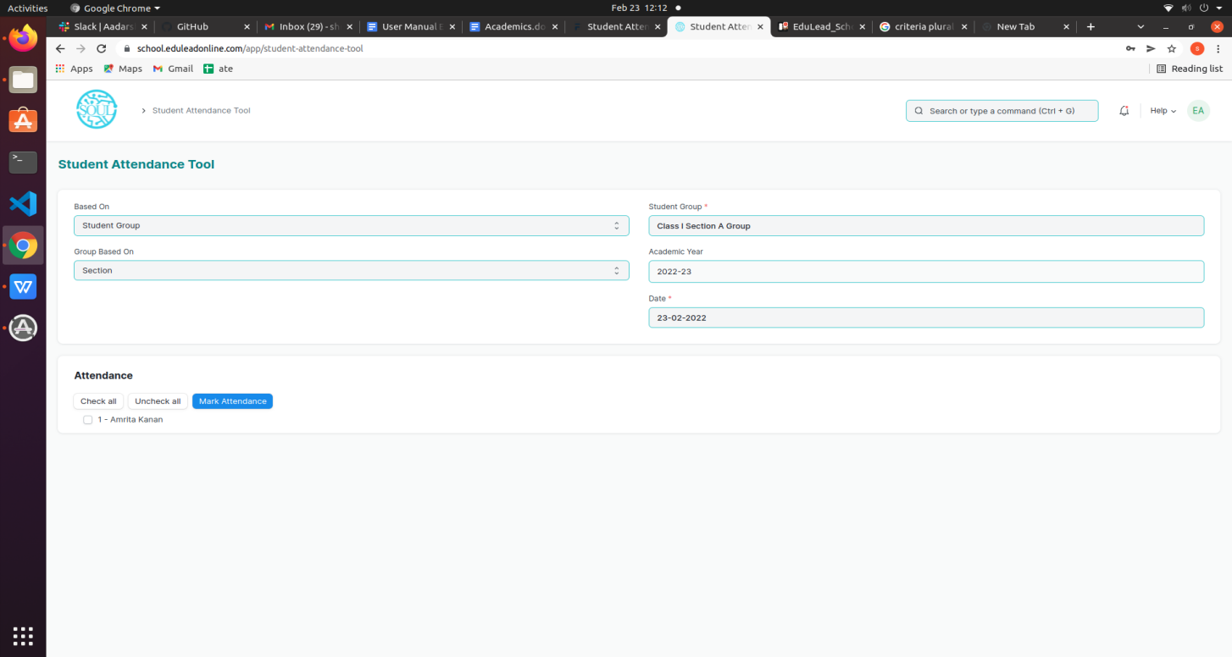

#### Prerequisites

Before using Student Attendance Tool, it is advisable that you create the following first:

1. Student
2. Subject Schedule
3. Student Group

#### 

#### How to use a Student Attendance Tool?

1. Go to the Student Attendance Tool.
2. Select and Enter the ‘Based On’ from the drop-down menu

a.Student Group: Select and Enter ‘Group Based On(Batch/Section/Activity/Subject),

Student Group,Academic Year and Date.

b.Subject Schedule: Select and Enter Academic Year and Subject Schedule.

1. Students will be automatically fetched.
2. Mark the Attendance.
3. Save.

The entries for all the Students’ Attendance Tool is created in the Student Attendance Document.

## Assignment & Study Material Uploads

Assignment & Study Material Uploads consists of transactions which would allow to upload assignments,Study Materials and so on and also helps students to submit assignments and answer sheets. The transactions in Assignment & Study Material Uploads consists of:

1. Assignment Master
2. Upload Material
3. Received Assignment

### 4.1 Assignment Master

Assignment Master helps to specify the type of Study Material like Project,Quiz,Homework and so on and also specify the characteristics of material like Self-learning,Teacher-evaluating and so on.

To access the Assignment Master, go to

Home > School- Academics > Assignment & Study Material Uploads > Assignment Master

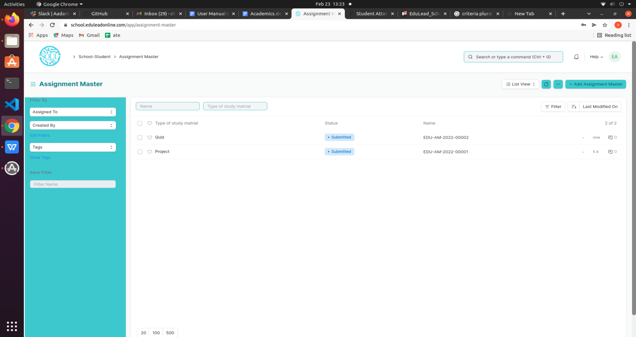

### 

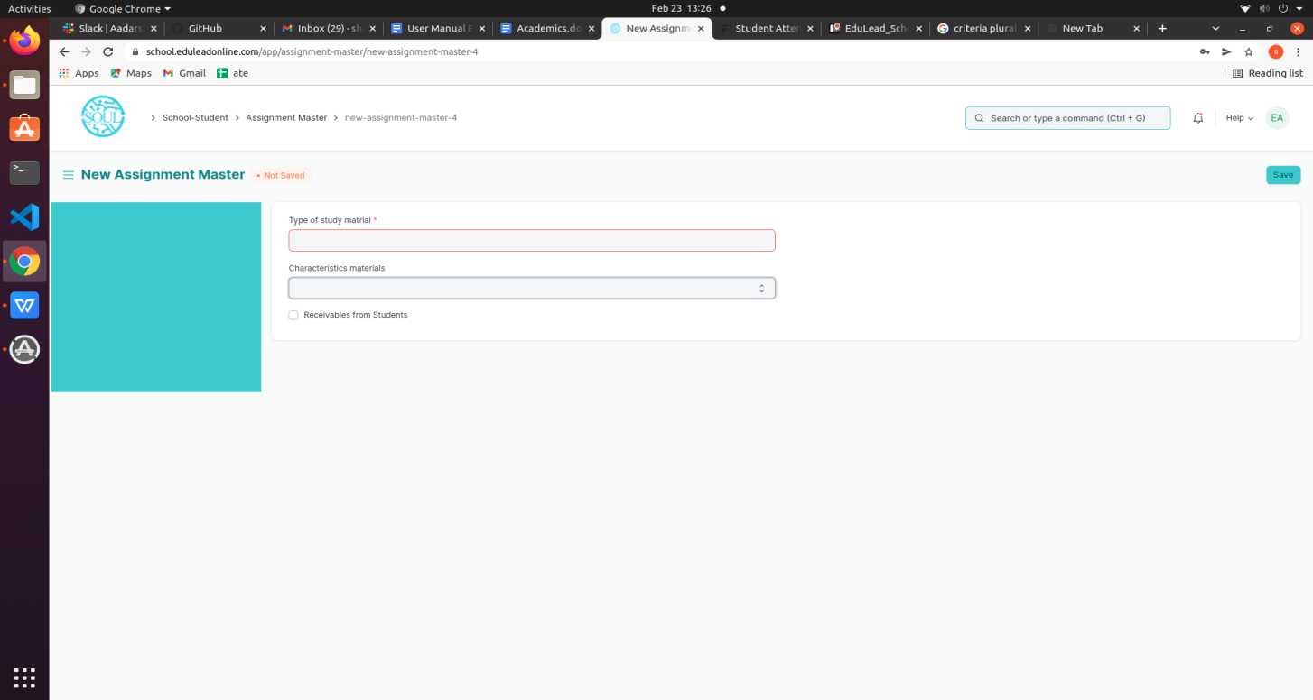

#### 

#### How to create an Assignment Master?

1. Go to the Assignment Master list and click on ‘Add Assignment Master’.
2. Select and enter Type of the material.
3. Select and enter Characteristic Material from the drop down menu.
4. Save and Submit.

### 4.2 Upload Material

Upload Material helps to upload Study Material like Project,Quiz,Homework and so on .A teacher can attach Video and Documents via upload material for specific class and student groups.

To access the Upload Material, go to

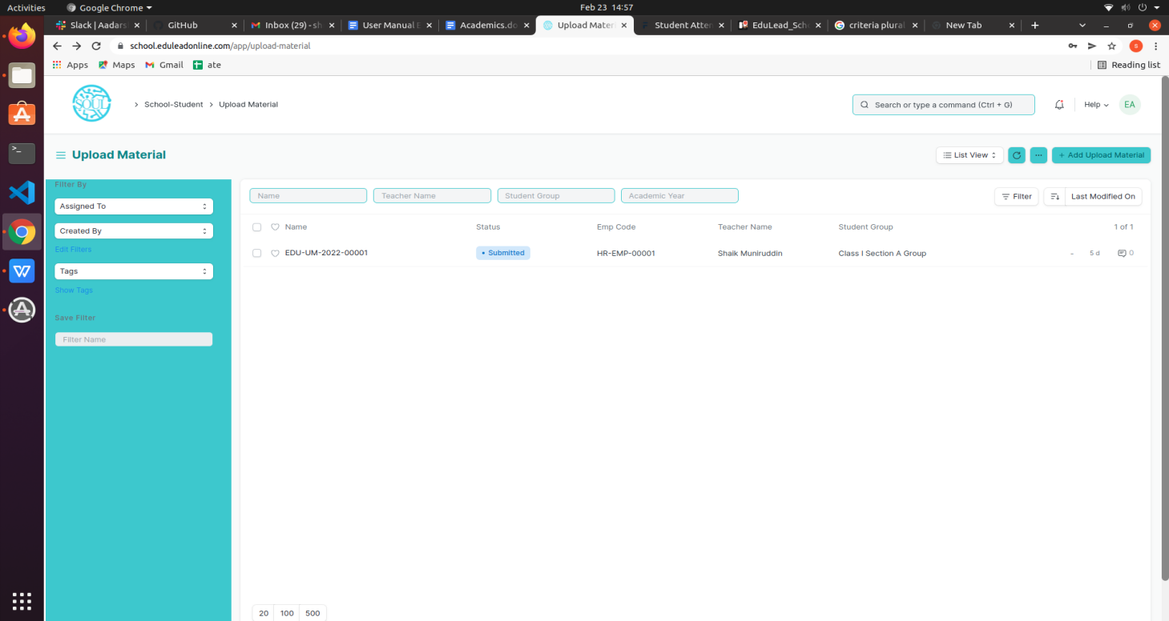 Home > School- Academics > Assignment & Study Material Uploads > Upload Material

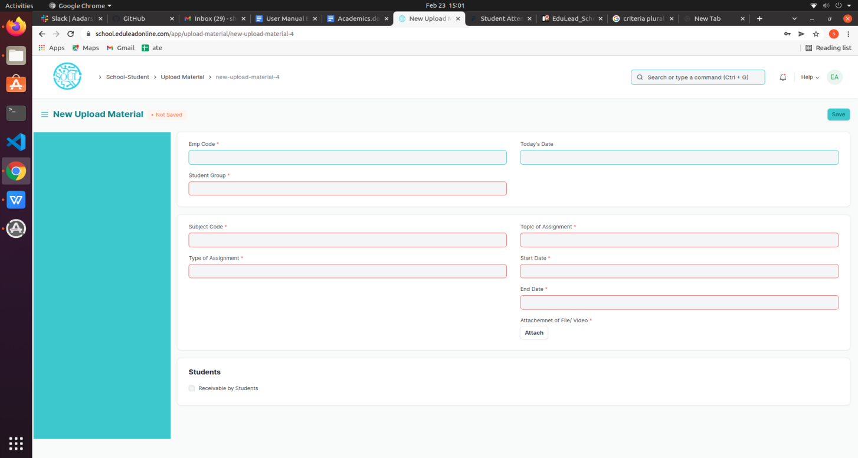

#### Prerequisites

Before creating Upload Material, it is advisable that you create the following first:

1. Assignment Master
2. Teacher
3. Student Group
4. Subject

#### How to create an Upload Material?

1. Go to the Upload Material list and click on ‘Add Upload Material’.
2. Select and enter Employee/Teacher.
3. Select and enter the Student Group;On entering student group Class,Section and Academic Year will be auto-fetched.
4. Select and enter the Subject and Type of Assignment from the drop-down menu.
5. Select and enter Topic of Assignment.
6. Set Start Date and End Date for the Assignment.
7. Attach the file
8. Check ‘Receivable by Student’ checkbox.
9. Save and Submit.

### 

### 4.3 Received Assignment

Received Assignment allows you to view the assignment and answer sheets uploaded by the Student for the given assignments and Quiz.

To access the Received Assignment, go to

Home > School- Academics > Assignment & Study Material Uploads > Received Assignment

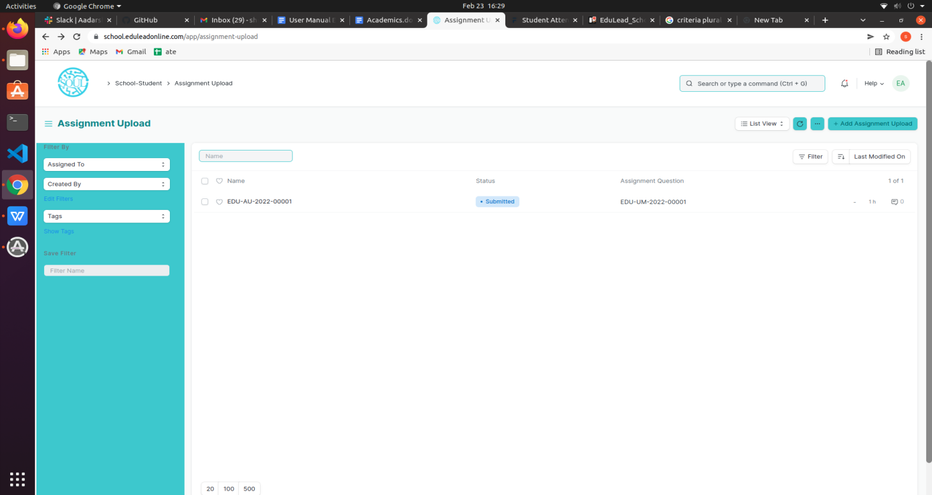

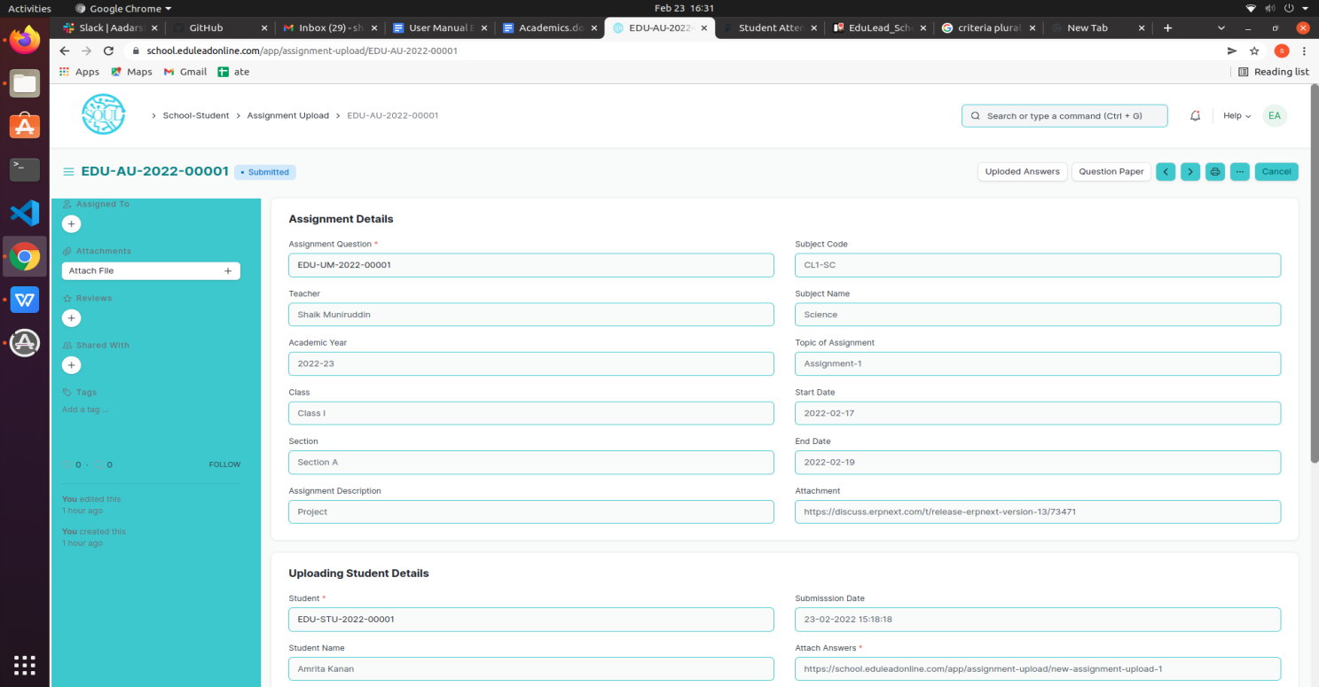

#### Prerequisites

Before creating Received Assignment, it is advisable that you create the following first:

1. Assignment Master
2. Upload Material
3. Student

#### How to create a Received Assignment?(From Student Login)

1. Go to the Received Assignment list and click on ‘Add Assignment Upload’.
2. Select and enter the Question;details like question,class,section,teacher and so on will be auto fetched.
3. Select and enter the Student.
4. Attach the assignment or answer sheet.
5. Save and Submit.

## Feedback

Feedback consists of transactions which allow you to give feedback to teachers and also helps to raise queries for admin. The transactions in Assignment & Study Material Uploads consists of:

1. Teacher’s Feedback
2. Admin Changes

### 5.1 Teacher’s Feedback

Teacher’s Feedback helps Students to give feedback to Teachers.

To access the Teacher’s Feedback, go to

Home > School- Academics > Feedback > Teacher’s Feedback

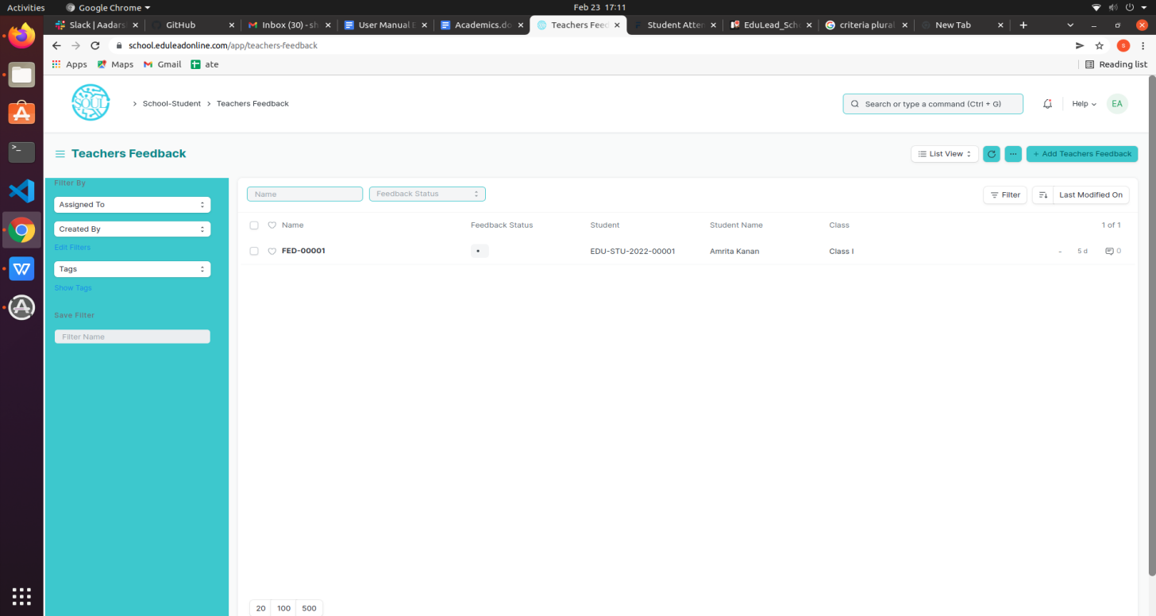

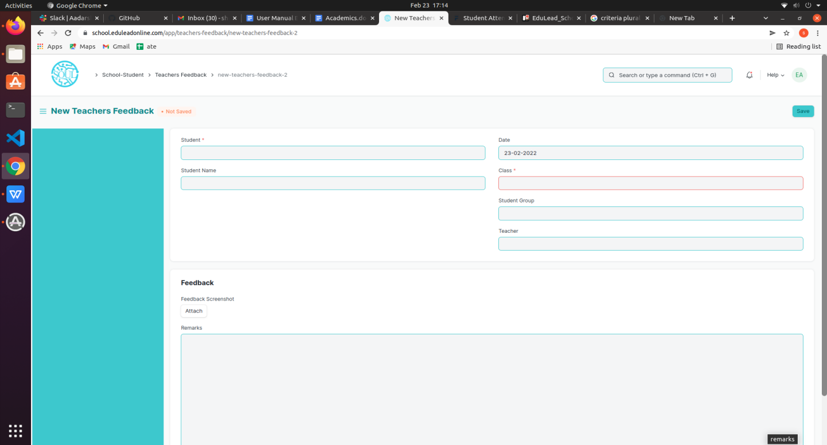

#### Prerequisites

Before creating Teacher’s Feedback, it is advisable that you create the following first:

1. Student
2. Class
3. Student Group
4. Teacher

#### How to create a Teacher's Feedback?

1. Go to the Teacher’s Feedback list and click on ‘Add Teachers Feedback’.
2. Select and enter the Student.
3. Select and enter the Class And Student Group.
4. Select and enter the Teacher for which feedback is to be given.
5. Give Remarks.
6. Attach the screenshot of the feedback(if any).
7. Save and Submit.

### 5.2 Admin Changes

Admin Changes helps the Users to raise any queries to admin(like changing of password).

To access the Teacher’s Feedback, go to

Home > School- Academics > Feedback > Admin Changes

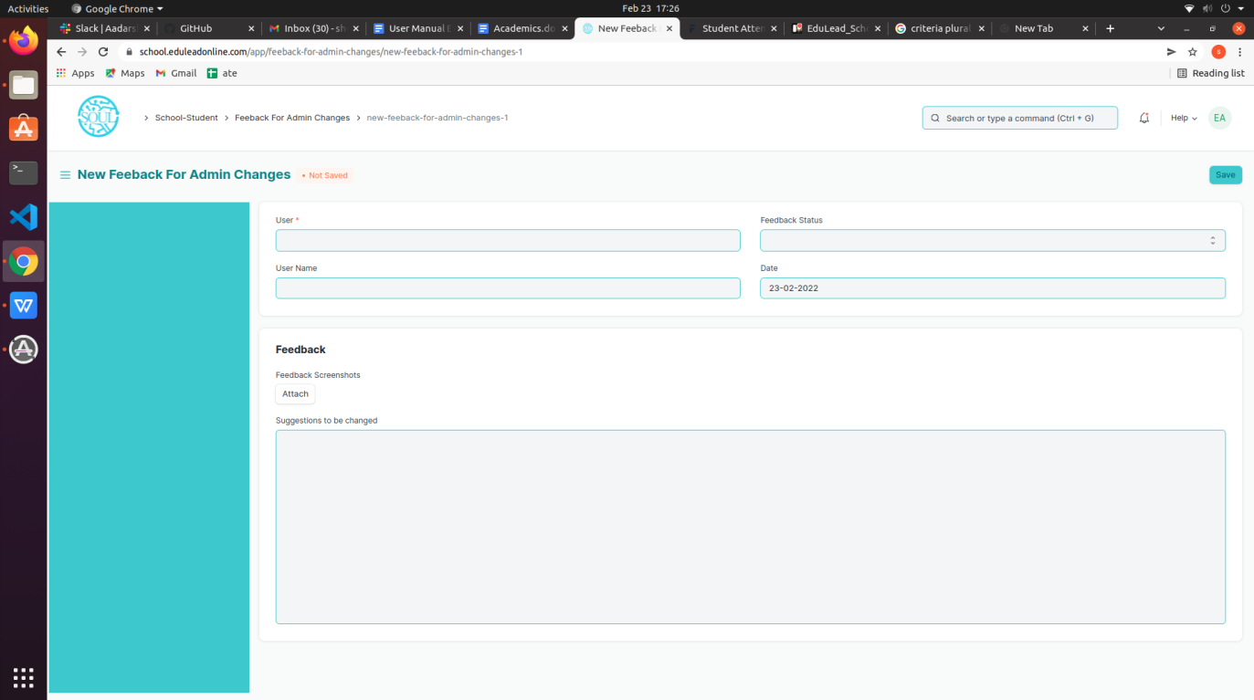

#### Prerequisites

Before creating Admin Changes, it is advisable that you create the following first:

1. Users

#### How to create Admin Changes?

1. Go to the Admin Changes list and click on ‘Add Feedback for Admin Changes’.
2. Select and enter the User.
3. Select and enter the Suggestion for the Change.
4. Attach the screenshot for the query(if any)..
5. Give Remarks.
6. Attach the screenshot of the feedback(if any).
7. Save and Submit